**Week 6 – LAB 4**

**1.First question:**

Write a java program that asks the user to enter two positive numbers. If the user enters a negative number, then the program keeps asking him\her to renter a positive one. Finally, the program prints the sum of the two numbers.

**Typical run of the program**

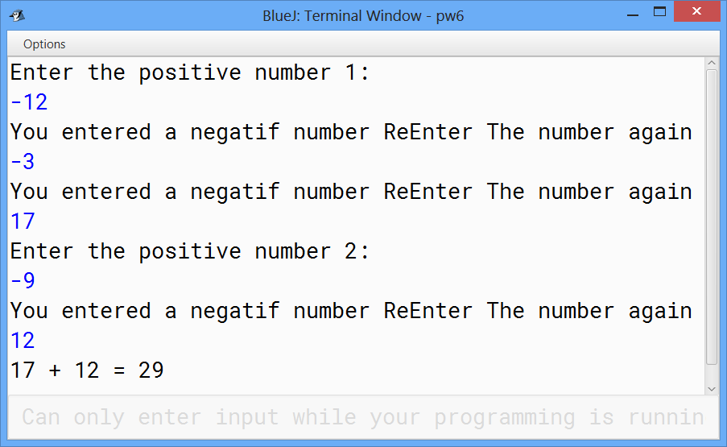

**Solution:**

import java.util.Scanner;

public class Question1 {

public static void main(String[] args) {

Scanner in = new Scanner(System.in);

int num1;

int num2;

System.out.println("Enter the positive number 1: ");

num1 = in.nextInt();

while (num1 < 0 ) {

System.out.print("You entered a negative number ");

System.out.println("Re-enter The number again");

num1 = in.nextInt();

}

System.out.println("Enter the positive number 2: ");

num2 = in.nextInt();

while (num2 < 0) {

System.out.print("You entered a negative number ");

System.out.println("Re-enter The number again");

num2 = in.nextInt();

}

System.out.println(num1 + " + " + num2 + " = " + (num1 + num2) );

}

}

**2.Second question:**

Write a java program that asks the user to enter his\her grade. The grade must be between 0 and 100, and then print if the user succeed or fail. To succeed the grade must be greater than 60.

**Typical run of the program**

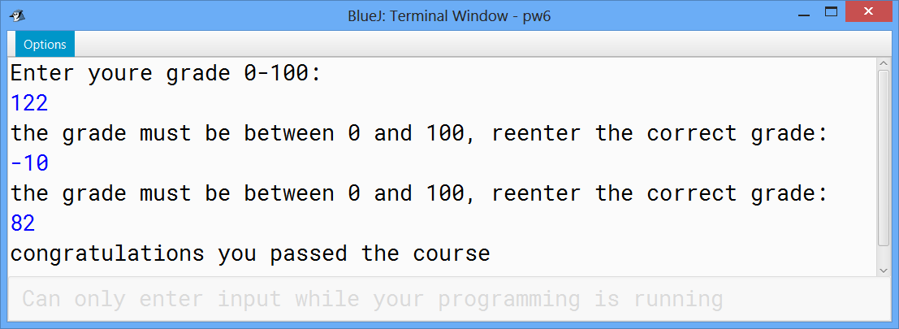

**Solution:**

import java.util.Scanner;

public class Question2 {

public static void main(String[] args) {

Scanner in = new Scanner(System.in);

int grade;

System.out.println("Enter youre grade 0-100: ");

grade = in.nextInt();

while (grade < 0 || grade>100 ) {

System.out.println("the grade must be between 0 and 100, reenter

the correct grade: ");

grade = in.nextInt();

}

if(grade >=60 )

System.out.println("congratulations you passed the course");

else

System.out.println("you failed the course");

}

}

**3.Third question:**

Write a java program, using the while loop, that:

* Ask the user to give a positive number less than 100.
* Print all the numbers from the given number to 200.

**Typical run of the program**

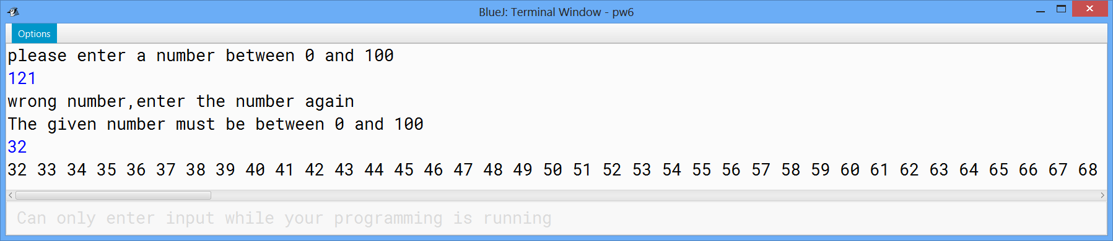

**Solution:**

import java.util.Scanner;

public class Question4 {

public static void main(String[] args) {

int number;

Scanner in = new Scanner(System.in);

System.out.println("please enter a number between 0 and 100");

number = in.nextInt();

while (number<0 || number>100) {

System.out.println("wrong number,enter the number again ");

System.out.println("The given number must be between 0 and 100");

number = in.nextInt();

}

for(int i= number; i<=200; i++)

System.out.print(i+" ");

}

}

**4.Fourth question:**

Write a java program that asks the user to enter a number between 50 and 100 then print all the multiple of 5 from zero to the given number.

**Typical run of the program**

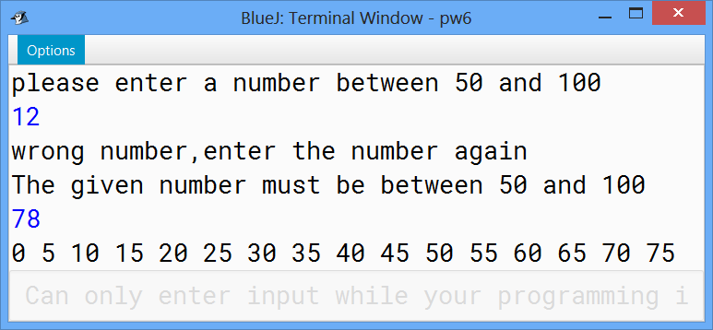

**Solution:**

import java.util.Scanner;

public class Question4 {

public static void main(String[] args) {

int number;

Scanner in = new Scanner(System.in);

System.out.println("please enter a number between 50 and 100");

number = in.nextInt();

while (number<50 || number>100) {

System.out.println("wrong number,enter the number again ");

System.out.println("The given number must be between 50 and 100");

number = in.nextInt();

}

for(int i= 0; i<=number; i=i+5)

System.out.print(i+" ");

}

}

**5. Fifth question:**

 Write a java program that act as a simple calculator using the switch statement.

**Typical run of the program**

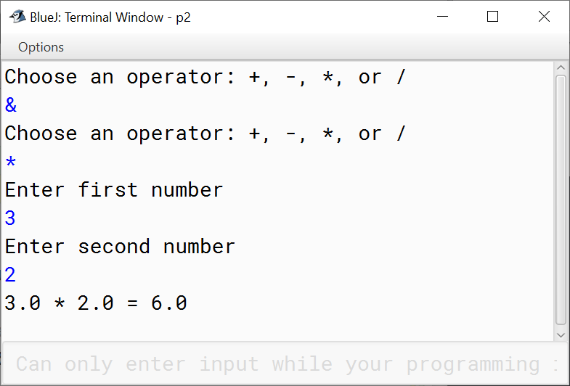

**Solution :**

import java.util.Scanner;

public class Week6 {

public static void main(String[] args) {

char operator;

Double number1, number2, result;

// create an object of Scanner class

Scanner input = new Scanner(System.in);

// ask users to enter operator

do{

System.out.println("Choose an operator: +, -, *, or /");

operator = input.next().charAt(0);

}while(operator!='+' && operator!='-' && operator!='*' && operator!='/');

// ask users to enter numbers

System.out.println("Enter first number");

number1 = input.nextDouble();

System.out.println("Enter second number");

number2 = input.nextDouble();

switch (operator) {

// performs addition between numbers

case '+':

result = number1 + number2;

System.out.println(number1 + " + " + number2 + " = " + result);

break;

// performs subtraction between numbers

case '-':

result = number1 - number2;

System.out.println(number1 + " - " + number2 + " = " + result);

break;

// performs multiplication between numbers

case '*':

result = number1 * number2;

System.out.println(number1 + " * " + number2 + " = " + result);

break;

// performs division between numbers

case '/':

result = number1 / number2;

System.out.println(number1 + " / " + number2 + " = " + result);

break;

default:

System.out.println("Invalid operator!");

break;

}

}

}